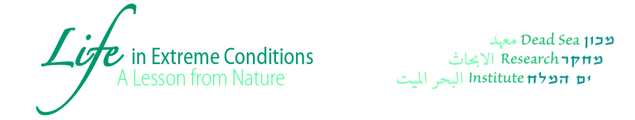

The Dead Sea Research Institute

***Second*** *global scientific summit*

**Life in Extreme Conditions – A Lesson from Nature**

**March 11-13, 2019**

*“The reasonable man adapts himself to the world:*

*the unreasonable one persists in trying to adapt the world to himself.*

*Therefore all progress depends on the unreasonable man.”*

*-- George Bernard Shaw, Man and Superman, 1901*

The Dead Sea is a unique region of seminal global importance.

The goal of this second global summit is the fundamental and comprehensive “Lesson from Nature” to be learned, from this region, especially nowadays, given the climate change threat, but not only. Lessons about natural selection and evolution in extreme conditions, the adaption of plants and animals, and other broadband aspects from human survival to culture. These lessons must be verified, evaluated and discussed in order to *balance reasonable and unreasonable progress* for the benefit of all.

The Dead Sea region is part of the Great Rift Valley, the longest geological feature on earth and the pathway of civilization. It is the lowest inhabited place on earth, about 430m below sea level, the most saline lake with about 32% w/v of a salt mixture. It is inimitable in its extraordinary combination of nature’s basic elements – Air, Sun, Earth (Mud) and Water – unparalleled anywhere else on earth. This creates a unique micro and macro biological environment, unique geography, geology, climate, minerals, flora, fauna. It is also the cradle of human civilization with a long heritage of industry, therapeutic and cultural activities.

The Dead Sea Research Institute in Masada is committed to investigating all aspects, from new materials, extremophiles biology, nanotechnology, energy, geophysics, seismology, sociology up to anthropology, disaster mitigation, environmental studies, health, microbiome, and more.

Thus, this second Dead Sea summit targets innovation, creativity, sharing, and brainstorming to further explore the *Life in Extreme Conditions* of this place on earth, at this time. A lesson from nature towards translational science for the wellbeing of the planet and humanity.

**“**As there’s nothing more powerful than an idea whose time has come” [Victor Hugo].

**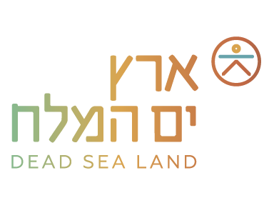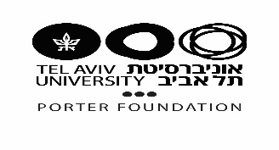**

**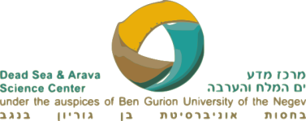**



**Monday, March 11th**

10:00 – 10:30 **Greetings & Opening Remarks**

Dov Litvinoff - Mayor, Tamar Regional Council in Israel’s Southern District

Prof. Joseph Klafter - President, Tel Aviv University (TAU)

Prof. Yona Chen - ICA Board of Directors

Porter Foundation - Dame Shirley Porter, Founder

10:30 – 12:30 **Opening session:**

Chair: Prof. Ehud Gazit - Faculty of Life Sciences, Academic Director of the BLAVATNIK CENTER for Drug Discovery, Head of the Laura Schwartz-Kipp Institute for Biotechnology, TAU

*The Dead Sea: from the past to the future*

Prof. Colin Price - Department of Geophysics, Head of the Department of Environmental Studies, Porter School of the Environment and Earth Sciences, TAU

*Treasures & Uniqueness of the Dead Sea region*

Dr. Mira Marcus-Kalish- Director, International Research Affairs, TAU, VC Medical Informatics HBP

***Keynote***

*Advances in Soft Materials and their Impact on Aging Population*

*and the environment*

Prof. Samuel I. Stupp – Departments of Chemistry, Materials Science & Engineering,

Medicine, and Biomedical Engineering Simpson Querrey Institute for Bio-Inspired Science

and Technologies

***Keynote***

*Microbiome - a New Frontier That Might Just Affect Everything*

Prof. George Weinstock - Evnin Family Chair and Director of Microbial Genomics, Jackson Laboratory for Genomic Medicine, USA

12:30 – 13:30 Lunch



13:30– 15:30 **Session II: Microbiome**

Chair: Prof. Eliora Ron - President Elect of IUMS (International Union of Microbiological Societies), George S. Wise Faculty of Life Sciences, TAU

*Effect of exposure to sun on skin microbiome*

Dr. Nurit Harel - School of Molecular Cell Biology and Biotechnology, George S. Wise Faculty of Life Sciences, TAU

*From halophilic viruses to antibiotic resistance*

Prof. Uri Gophna - School of Molecular Cell Biology and Biotechnology, George S. Wise Faculty of Life Sciences, TAU

*The Terrestrial Holobiont: Ecological, agricultural and medical research*

Dr. Amir Szitenberg - Dead Sea & Arava Science Center

*Effect of E. coli vaccines on the microbiome*

Dr. Mariagrazia Pizza - Discovery Project Leader R&D Centre GSK Vaccines

*Microbial Variety in Desert Trees*

Dr. Ashraf Al Ashhab - Dead Sea & Arava Science Center

15:30 – 16:00 Coffee Break

16:00- 18:00 **Session III: Geophysics/ Climate**

Chair: Prof. Yaron Oz - Rector, TAU

*Lessons from the longest earthquake record in the world*

Prof. Shmuel Marco - Department of Geophysical, head of the Porter school of the

Environmental and Earth Sciences, TAU

*Scientific, Political, and Ethical Challenges Facing a Sustainable Anthropocene*

Prof. Jagadish Shukla - The Center for Ocean-Land-Atmosphere Studies,George Mason University USA



*Depletion, degradation, diversion – the death and life of inland seas as global policy challenge*

Prof. David L. Feldman - Urban Planning and Public Policy, School of Social Ecology

University of California, Irvine, USA

*The Dead Sea rift as a unique site for sensor calibration from orbit*

Prof. Eyal Ben-Dor - Department of geography, Porter school for environment study and earth science, TAU

*First High-resolution Dead Sea Studies employing remote sensing and*

*Meteorological model*

Prof. Pinhas Alpert - Atmospheric Sciences, the Mikhael M. Nebenzahl and Amalia Grossberg Chair Professor in Geodynamics, Porter school for environment study and earth science, TAU

*Pushing the limits of Earthquake Early Warning Systems: Is it time for*

*A paradigm shift?*

Dr. Hillel Bloch - Department of Geophysical, Atmospheric and Planetary Sciences,

Raymond and Beverly Sackler Faculty of Exact Sciences, TAU

19:00 Dinner

**Tuesday, March 12th**

09:00 – 10:30 **Session IV: Health – Extreme Responses to Extreme Conditions**

Greetings: Prof. Oliver Gunter - President, Potsdam University

Chair: Prof. Mauro Ferrari - President and CEO, Houston Methodist Research Institute, Director, Executive Vice President, Houston Methodist Hospital, USA

*Evidence-based therapeutic properties of the Dead Sea* Dr. Marco Harari, MD - Joint Research Institute on Climatotherapy for Skin Diseases at the Dead Sea, Hadassah Medical Center and Dead Sea & Science Center

*Apple of Sodom (Calatropis procera) callus, a novel skincare active compound*

Dr. Zeev Ma’or - CTO R&D, AHAVA - Dead Sea Laboratories

*Expanding the Horizon for skin Restoration*

Dr. Michael S. Perry - Chief Executive Officer AVITA medical, USA



10:30 – 11:00 Coffee Break

11:00 – 12:30 **Session V: Health**

Chair: Prof. Karen B. Avraham- Vice Dean, Sackler Faculty of Medicine

*A novel platform for manipulating genes in health and diseases.*

Prof. Dan Peer - Managing Director, Center for Translational Medicine, Department of Cell Research & Immunology, Chair, Cancer Biology Research Center, Faculty of Life Science, TAU.

*Understanding Individual Pathogenesis of Orthopedic Conditions and Integrative Approaches for Treatment*.

Prof. Frank-Norbert Bittmann- Head of the Department of Regulatory Physiology and Prevention, Potsdam University

*Desert Chemistry for Drug discovery targetting Cancer and Brain Research*

Dr. Rivka Ofir- The Dead Sea & Arava Science Center

*Pathways to a Cure: Space Age for the Aging Space*

Prof. Mauro Ferrari- Chairperson, International Board of Governors Dead Sea

Research Institute (DSRI)

12:30– 13:30 Lunch

13:30 – 15:30 **Session VI: Zoology – Adaptation to Extreme Conditions**

Chair: Prof. Yoav Henis - VP R&D TAU

*Are you a morning or an evening person? The adaptive significance of chronotypes*

Prof. Noga Kronfeld-Schor - Head, School of Zoology, Head of Ecological and Evolutionary Physiology Laboratory, Faculty of Life Sciences, TAU

*Using computer simulations and experiments to predict biological impacts of Climate change*

Dr. Ofir Levy - School of Zoology, George S. Wise Faculty of Life Sciences, TAU



*Diverse Functions of Torpor*

Prof. Fritz Geiser - Director, Centre for Behavioral and Physiological Ecology (BPE), School of Environmental and Rural Science, New England University, Australia

*Surviving the long, cold, and dark: Animal strategies for overwintering in the Arctic*

Prof. Brian Barnes - Director, Institute of Arctic Biology, Professor of Zoophysiology, University of Alaska Fairbanks

*Sugar as a source for antioxidant for nectarivores*

Prof. Eran Levin - Zoology school, George S. Wise Faculty of Life Sciences, TAU

15:30-16:00 Coffee break

16:00 – 18:00 Masada Excavation

A guided tour with Dr. Guy Stiebel- Institute of Archeology, Lester and Sally

Entin Faculty of Humanities, TAU

18:00 – 19:00 **Session VII: Humanities**

Chair: David Benshabat - Director Dead Sea Research Institute, Head of Center for Regional Thinking

*Writing Blooms in the Desert*

Prof. Jonathan Price - The Fred and Helen Lessing Chair of Ancient History, Lester and Sally Entin Faculty of Humanities, TAU

*Regional Peace Activities in Extreme Conditions – From Owls to Space*

Prof. Yossi Leshem– Department of Zoology, George S. Wise Faculty of Life Sciences, TAU

20:00 Dinner at Ein Gedi Outdoorsevent1273_1



**Wednesday, March 13th**

09:00 – 10:30 **Session VIII: Botanic/Ecology/Energy**

Chair: Prof. Abdussalam Azem - Dean, George Wise Faculty of Life sciences, TAU

*How hydrogen production can be used to study and engineer photosynthesis to the extreme*

Dr. Iftach Yacoby – Head of the laboratory for renewable energy studies, School of Plant Sciences and Food Security, George S. Wise Faculty of Life Sciences, TAU

*Inorganic life of plants*

Dr. Ofir Katz - Dead Sea & Arava Science Center

*Mechanisms that monitor the development of plants in response to heat stress, drought and salt*

Prof. Shaul Yalovsky - School of Plant Sciences and Food Security, George S. Wise Faculty of Life Sciences, TAU

***Keynote****: The Taken-for-granted Supply Chain*

Prof. Jonathan Trent - Director, OMEGA Global Initiative; Biomolecular Engineering, UC Santa Cruz, NASA, USA

10:30 – 11:00 Coffee Break

11:00 – 12:10 **Session IX: Humanities**

Chair: Prof. Raanan Rein - Vice President, TAU

*The Dead Sea Genome*

Prof. Noam Mizrachi – Acting Chair, Department of Biblical Studies, Faculty of Humanities

*Millefiori - the reconstruction of Herod's royal horticulture*

Dr. Dafna Langgut - Head of the Laboratory of Archaeobotany and Ancient Environments at the Institute of Archaeology, TAU



**Keynote:** *The Globalization of Science*

Prof. Alan I. Leshner- Chief Executive Officer, Emeritus, AAAS and former Executive Publisher, Science, USA

12:10 – 13:30 **Panel Discussion - Joint Collaboration Opportunities**

Prof. Mauro Ferrari - President and CEO, Houston Methodist Research Institute, Director, Executive Vice President, Houston Methodist Hospital, USA

Prof. Alan I. Leshner - Chief Executive Officer, Emeritus, AAAS and former Executive

Publisher, Science, USA

Prof. Theng Yin Leng - Research Director, Research Strategy & Coordination Unit, President's Office, Nanyang Technological University, Singapore

Dr. Rino Rappuoli - Chief Scientist & Head of External R&D GlaxoSmithKline (GSK) Vaccines

Prof. Dana Burr Bradley - Dean, Erickson School of Aging Studies, Professor of Social Gerontology, University of Maryland, USA

**Concluding Remarks**

13:30 – 14:30 Lunch

**Return to Tel Aviv**



